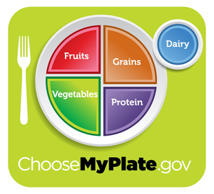

**First –Tour ChooseMyPlate.gov**

Click on green *Super Tracker & Other Tools* then click on *Daily Food Plan*, under Daily Food Plan (written big in fuscia) click on Daily Food Plan again written in blue. Do NOT go under topics. Based on your gender, age and activity level, what are your recommended amounts of each food group per day?

**Total Calories__________________**

**Grains ___________ oz.**

**Vegetables ___________ cups**

**Fruits ___________ cups**

**Milk ___________ cups Aim for ____ tsp of Oil a day.**

**Meat & Beans ___________ oz “Empty” calories (Fat & Sugars) ___________**

**Physical Activity (written in green)**

How much moderate or vigorous physical activity is recommend per day?__________________

**My Plate (written in green, find food group)**

**Grains**

What are Whole Grains? _______________________________________________________

List 5

1.

2.

3.

4.

5.

What are Refined grains? __________________________________________________________

List 5

1.

2.

3.

4.

**Vegetables** – *learn more…*

What are the 5 subgroups and 2 samples from each?

1. a) b)

2. a) b)

3. a) b)

4. a) b)

5. a) b)

**Fruits** – *learn more…*

Look through the list of ***Tips to help you eat fruits*** (it’s long). What 3 would you consider trying?

1.

2.

3.

**Oils** – *learn more…*

What 2 plant oils are high in saturated fat and should be considered solid fat?

1.

2.

**Milk** *– learn more….*

What are the 3 main nutrients the milk group provides?

1. 2. 3.

**Meat Group**

How should meats be prepared to keep it lean?

1. 2. 3.

**Empty Calories: Click on My Plate, go down to right side and click on “empty calories”**

What are added sugars?

List your top 3 food choices that contain the most added sugars? What might you do to reduce?

1. 2. 3.

***Tips and Resources***

**Tips for Eating Out**: Under Healthy Eating Tips

List 4 tips from the *long list* that you would consider doing!

1.

2.

3.

4.